**Group Number: A24**



**A**

**MINI PROJECT REPORT ON**

## “LASER HOME SECURITY”

**SUBMITTED TO SAVITRIBAI PHULE PUNE UNIVERSITY, PUNE IN THE FULFILLMENT OF THE REQUIREMENTS**

**FOR THE COMPLETION OF MINI PROJECT**

**OF**

#### THIRD YEAR ENGINEERING IN

**ELECTRONICS & TELECOMMUNICATION**

**BY**

## Chaitanya Waghmare Exam No. T190233331

**Kunal Chavan Exam No. T190233061**

## Purushottam Deshmukh Exam No. T190233068

**UNDER THE GUIDANCE OF**

#### Prof. A. D. VIDHATE

**DEPARTMENT OF ELECTRONICS & TELECOMMUNICATION ENGINEERING**

#### SINHGAD COLLEGE OF ENGINEERING

**S. No. 44/1, OFF SINHGAD ROAD, VADGAON BK, PUNE – 411041**

#### MAY 2023

**(2022-23)**



**CERTIFICATE**

This is to certify that the Mini Project entitled

## “LASER HOME SECURITY”

###### Submitted By

Chaitanya Waghmare Kunal Chavan

Purushottam Deshmukh

is a bonafide work carried out by them under the supervision of **Prof. A.D. VIDHATE** and it is approved for the partial fulfillment of the requirements of T.E. E&TC Engineering submitted to Savitribai Phule Pune University, Pune.

The Mini Project work has not been earlier submitted to any other institute or university for the award of degree or diploma.

|  |  |  |
| --- | --- | --- |
| **Prof. A. D. Vidhate**  Guide | **Dr. M. B. Mali**  Head | **Dr. S. D. Lokhande**  Principal |
| Department of E&TC | Department of E&TC | SCOE, Pune |
| **Place:** Pune  **Date:** |  |  |

## ACKNOWLEDGEMENT

We are feeling very humble in expressing my gratitude. It will be unfair to bind the precious help and support which we got from many people in few words. But words are the only media of expressing one’s feelings and my feeling of gratitude is absolutely beyond thesewords. It would be my pride to take this opportunity to say the thanks.

Firstly, we would thank our beloved guide **Prof. A.D.Vidhate** for his valuable guidance, patience and support; He was always there to force us a bit forward to get the work done properly and on time. He has always given us freedom to do mini project work and the chance to work under his supervision.

We would like to express our sincere thanks to **Dr. D. G. Ganage**, mini project coordinator, Department of E&TC, for her constant encouragement in the fulfillment of the mini project work. We would also like to express our sincere thanks to **Dr. M. B. Mali, Head,** Department of E&TC for his co-operation and useful suggestions. We would also like to thank **Dr. S. D. Lokhande, Principal, Sinhgad College of Engineering.** He always remains a source of inspiration for us to work hard and dedicatedly.

It is the love and blessings of our families and friends which drove us to complete thisproject work.

Thank you all!

CHAITANYA WAGHMARE KUNAL CHAVAN

PURUSHOTTAM DESHMUKH

#### ABSTRACT

Technology develops day by day in the world. Now days the crime gang also improves their technology to carry out their operation. So technology of security should be modern with time to protect the world from crime. We decide to make a security issue as our project. In this project we have used laser beam to cover a large area. We know laser light goes to long distance without scattering effect. It's additionally obvious just at source and occurrence point, in any case invisible. These two properties help us to develop a modern security system, which may name as "Laser Security System." When any person or object crossover the laser light, automatically the buzzer starts ringing. Laser beam goes through long distance without scattering effect and the ray is almost invisible. The project involves the use of Arduino UNO, Laser light, Buzzer, LDR and a simple program. With these equipments we can easily set up a security alarm anywhere for unwanted intruders. A Laser Security System goes about as a standalone system, which makes sound or commotion when it distinguishes any sporadic action or can be part of a much bigger security or any other automation system which can alert owner.

TABLE OF CONTENTS

|  |  |
| --- | --- |
| **DESCRIPTION** | **PAGE NO** |
| **CHAPTER 1** | 1 |
| INTRODUCTION | 1 |
| PROBLEM STATEMENT | 1 |
| **CHAPTER 2** | 2 |
| LITURATURE SURVEY | 2 |
| **CHAPTER 3** | 3 |
| Block Diagram | 3 |
| Explanation | 3 |
| Circuit Diagram | 4 |
| Explanation | 4 |
| PCB Layout | 4 |
| Component Details | 5 |
| Hardware Details | 5 |
| Atmega 325p | 5 |
| LDR Module | 5 |
| LASER module | 6 |
| Buzzer | 6 |
| Jumping Wires | 6 |
| Software Details | 7 |
| Arduino Software(features) | 7 |
| Tinkercad: (Features) | 7 |
| Flowchart | 8 |
| **Chapter 4** | 8 |
| Result | 8 |
| Explanation | 8 |
| **Chapter 5** | 9 |
| Advantages | 9 |
| Disadvantages | 9 |
| Applications | 9 |
| Conclusion | 9 |
| **Chapter 6** | 10 |
| Future Scope | 10 |
| Appendix | 10 |
| Appendix A |  |
| Appendix B |  |
| References |  |

###### Table of Figures

Figure 1: Block Diagram 12

Figure 2: Circuit Diagram 13

Figure 3: PCB Layout of Arduino UNO 14

Figure 4: Arduino UNO R3 14

Figure 5: LDR LM393 Module 15

Figure 6: Ky-008 LASER Module 15

Figure 7: Breadboard 15

Figure 8: Active 2 pin Buzzer 15

Figure 9: Jumping Wires 15

Figure 10: Flowchart 17

Figure 101: Working Model 19

## Chapter.1 Introduction

1. Need of security is the necessity of any individual. The feeling that we are safe and everything around us is all right is imperative for a peaceful living. LASER trip wire, which will be monitoring a walkway. Upon turning this on if anyone trips it or falls on the laser, an alarm will be raised, which might scare the trespasser.
2. The idea of LASER (Light amplification by stimulated emission of radiation) based security system with LDR (Light dependent resistor), in which an alarm was sounded when an intruder as detected. LASER is highly directional and travels a very long range without losing sufficient power. LASER light even goes through long distance without scattering effect. It’s also visible only at the source and incident point; otherwise, invisible. In dark, a LDR can have a very high resistance (several mega ohms (MΩ)), while in the light; it can have a low resistance in the order of ohms. This property of LDR helps to sense LASER.

##### Problem Statement

1. Security has been a huge problem since the evolution of humankind, we have developed various types of security systems but are still trying to achieve more.
2. But in search of more powerful and efficient security system we tend to neglect the cost of that security system and hence only company with humongous funds can really implement those security methods.
3. In this project we need to design a LASER security system with LASER and light dependent resistor, which will protect the individuals, it is also cost effective and reliable to be used in home or shops, where earlier this wasn’t possible due to its high pricing.
4. But as we make advancement in technology, the price of components decreases also making it user friendly and cost effective, this gives the individuals a chance to get this security system installed in their place of interest.
5. Objective of this system is to secure and safely guard the entrance, and it makes the alarm go off if the LASER is tripped.
6. As this LASER security system is becoming affordable due to advancement in technology, the prejudice of LASER security only feasible for big companies and organization can be broken. More home and shops can use this cost effective and reliable security system if they wish to.

## CHAPTER 2

LITERATURE SURVEY

## Literature Survey

Security could be the most important factor in daily life. Need of security is that the basic necessity of every individual. The Sensation/feeling that we are safe and everything around us is all right is imperative for peaceful living. Be that because it may, during this unsafe world, when crime, terror, and dangers are at their pinnacle, how might one achieve that suspicion of safety? Here, a laser tripwire security system provides us with a solution and for this reason, more and more people are installing them to remain safe and secured. Different electronic security systems are often utilized at the house and other significant working spots for security and safety purposes. A laser tripwire Security system/ alarm is a device used for Safeguard/security purposes. It's a good application in fields of security and defense ranging from the security of a straightforward household material to a very high valued material of an organization. They once accustomed be very expensive solutions for security needs. Attributable to cost-cutting and fast technological advancements, this type of security system is becoming cheaper and more affordable. When the bad guys try to sneak up in the mid night, they kick the wire and pull over, making a rattle that awakens the sleeping good guys, who win the day. A laser tripwire security system works with the identical principle and working. Instead of a string, there's a ray of light surrounding the area, and instead of a can of rocks, there’s an alarm of one sort or another.

## Design and Development

**3.1. Block Diagram**

Explanation

Figure 3.1.1 Block Diagram

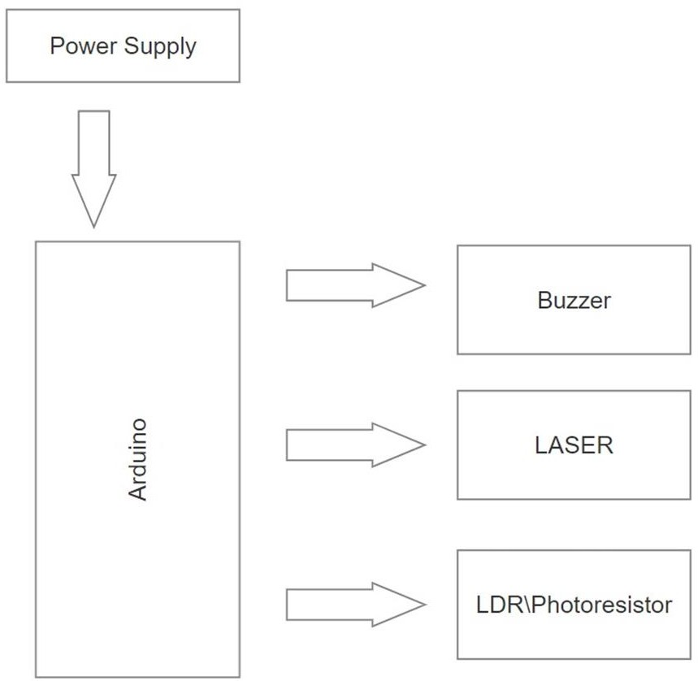

* + - Arduino, LASER module, a Buzzer, LDR module, the idea is very simple, the LASER is constantly projecting light to the module sensor, when a person or something passes through the light beam, the sensor will not detect the light anymore (When the light stops, the LDR will increase resistance, which means less current will pass, and we’ll get a voltage drop).
    - Hence, the Arduino turns on the buzzer and it can only be turned off by the owner physically. This circuit continuously repeats itself.

## Circuit Diagram

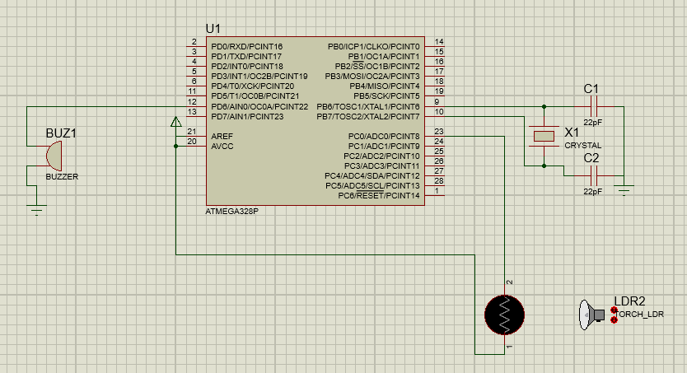

Figure 3.2.1 Circuit Diagram

### Explanation

* + 1. Here, we give DC supply to Arduino which is further supplying power to LASER, and LDR to power on, and we connect the buzzer to 13th number pin which supplies 5v power to it. Then we do ground connection to LASER, Buzzer, LDR.
    2. So when we power on the Arduino, it turns on LDR, LASER, Buzzer. It makes the LASER light fall on LDR which senses the light and the Arduino then decides whether to turn the buzzer on or off. If the threshold value is not attained the LDR stops sensing the light and then the Arduino turns on the buzzer.

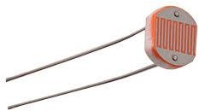

## Selection of components criteria

#### Component Details

##### Hardware Details:

* + 1. Arduino Uno r3:

1. Microcontroller - ATmega38P – 8 bit AVR family microcontroller
2. Digital I/O Pins - 14 (Out of which 6 provide PWM output)
3. DC Current on I/O Pins - 40mA
4. DC Current on 3.3V Pin - 50mA
5. Flash Memory 32 KB
6. LDR MODULE :

Probots LDR Light Sensor Module Digital + Analog with Output Buy Online Buy Online India Description: Easy to install using the sensitive type photosensitive resistance sensor the comparator output signal gives a clean and good waveform. **Driving ability is 15mA** with the adjustable potentiometer, it can adjust the brightness of the light.

Figure 3.2.2 LDR Module

1. JUMPER WIRES:

Jumper wires are **electrical wires with connector pins at each end**. They are used to connect two points in a circuit without soldering. You can use jumper wires to modify a circuit or diagnose problems in a circuit. Further, they are best used to bypass a part of the circuit that does not contain a resistor and is suspected to be bad.

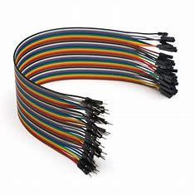

Figure 3.2.3 Jumper Wires

1. 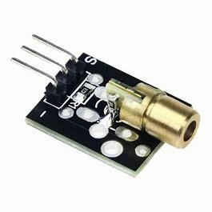LASER module KY-008:
   1. Wavelength: 650nm(red)
   2. Operating Voltage: 5v
   3. Range: Unlimited (in vacuum)
   4. Current Draw: 30mA

Figure 3.2.3 LASER Module KY-008

1. BUZZER: Buzzer (2-pin Active buzzer):
   1. Rated Voltage: 6V DC
   2. Operating Voltage: 4 to 8V DC
   3. Rated Current: ≤ 30mA
   4. Sound Output at 10cm: ≥ 85dB

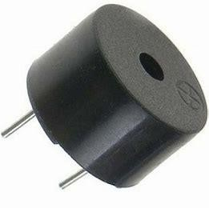

Figure 3.2.4 Buzzer

6

**TE *–* E&TC (2022-23)**

##### Software Details:

1. Arduino Software: (features)
2. Sketch Editing Tools
3. Libraries
4. Serial Monitor
5. Programmer Functions
6. Burn Bootloader
7. Auto Format
8. User Preferences
9. Board Selection & Management
10. Sketch Archive
11. Port Menu

Tinker cad: (features)

1. File Exportation.
2. File Editing.
3. 3D Designs.
4. Circuits.
5. Codeblocks.
6. Presets

|  |  |
| --- | --- |
| **TE *–* E&TC (2022-23)** |  |
| **CHAPTER 4 RESULT**  **Result**  Explanation:  In this project we setup a tripwire security system where the buzzer activates when an intruder tries to trespass into the property. In the above photo when the LASER gets tripped the alarm goes off and to stop it we have to manually restart the Arduino code. After restarting the code the alarm stops and again waits until the LASER gets tripped.    Figure 4.1 Hardware Result |  |

**CHAPTER 5 CONCLUSIONS**

# Advantages

1. To protect home and industry.
2. Easy to construct, parts of the circuit are easily available. 3. It reduced the man's effort. Accuracy of this circuit is more than accuracy of other circuits. 5. The cost of circuit is low.
3. They need very small power and voltage for its operation.

# Drawbacks

1. Unnecessary disturbances may occur while using in the apartments.
2. It is difficult to work with this equipment if there are no sufficient lightning conditions.

# Applications

1. Used for home security.
2. Used in the banks as a burglar alarm.
3. It can be used in jail to prevent prison break.
4. Used as automatic indicator
5. It can be used in mines areas to indicate restricted place.
6. Helps to keep you tabs on kids & notifies

## Chapter 6

**Future scope and conclusion**

#### Future scope

1. This security system is used in safeguarding bank vaults, museums, lockers, military, and Homeland security.
2. Furthermore, if we add more sensers we can make a camera capture the intruder if he trips the tripwire clicking his photo.
3. Then after adding a module, we can then send that photo to a cell phone alerting the owner.

#### Conclusion

The earliest security system comes from the early 1990's. They were very expensive at that time and hard to monitor an intrusion. Now the technology has developed very much more than the old days and now that the technology has evolved components are more affordable and user-friendly making this system easy to construct and install. This makes our project cost-effective and easy to construct.Our main purpose of creating this project was to study LASER security system and provide it with a cost-effective method to individuals. We do think that there will be more advancement in security systems making the individuals more secure and safe.

## References

1. Sudarshan B , Harshitha S , Janhavi K P Assistant Professor, Laser Based Security System, Department of ECE, K.S Institute of Technology, Bangalore, India Third Year B.E, Department of ECE, K.S Institute of Technology, Bangalore, India. IARJSET International
2. Advanced Research Journal in Science, Engineering and Technology Vol. 8, Issue 7, July 2021 DOI: 10.17148/IARJSET.2021.8715
3. K.Govinda K. Sai Krishna Prasad Sai ram susheel, Intrusion Detection System for Smart Home using Laser Rays, SCSE, University, Vellore, India, SENSE, VIT University Vellore, India. IJSRD - International Journal for Scientific Research & Development| Vol. 2, Issue 03, 2014 | ISSN (online): 2321-0613
4. https:/[/www.hunker.com/13419297/how](http://www.hunker.com/13419297/how-do-laser-security-systems-work)-[do-laser-security-systems-work](http://www.hunker.com/13419297/how-do-laser-security-systems-work)
5. https:/[/www.electronicshub.org/l](http://www.electronicshub.org/laser-security-system/)a[ser-security-system/](http://www.electronicshub.org/laser-security-system/)